**PTYD Sample Project Feedback**

Chris Lee

Overall, I understand the general structure of the data pipeline and also the logic behind the python code. I will need to familiarize myself with the CrateJoy, Google Apps, and Formstack API’s and the specific methods and functions for each. I think knowledge of the API’s will come while working more with them.

**Sample Project Implementation (Product Management-pulling product names from sheets):**

1. Created project in the Google Developers Console.
2. Downloaded Google Drive API and Google Sheets API.
3. Generated credentials JSON file and copied “client-email” value and shared email on Google Sheets.
4. Installed Oauth2 client using “pip install gspread oauth2client” in terminal
5. Built prodmanage.py script to extract product names from PTYD EXAMPLE PRODUCT INPUT SPREADSHEET
6. Ran script in terminal to print product names

creds.json file

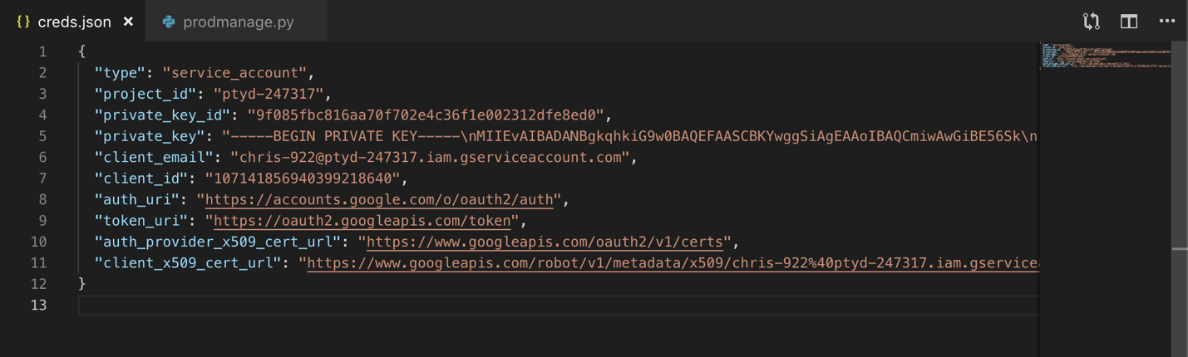

prodmange.py file

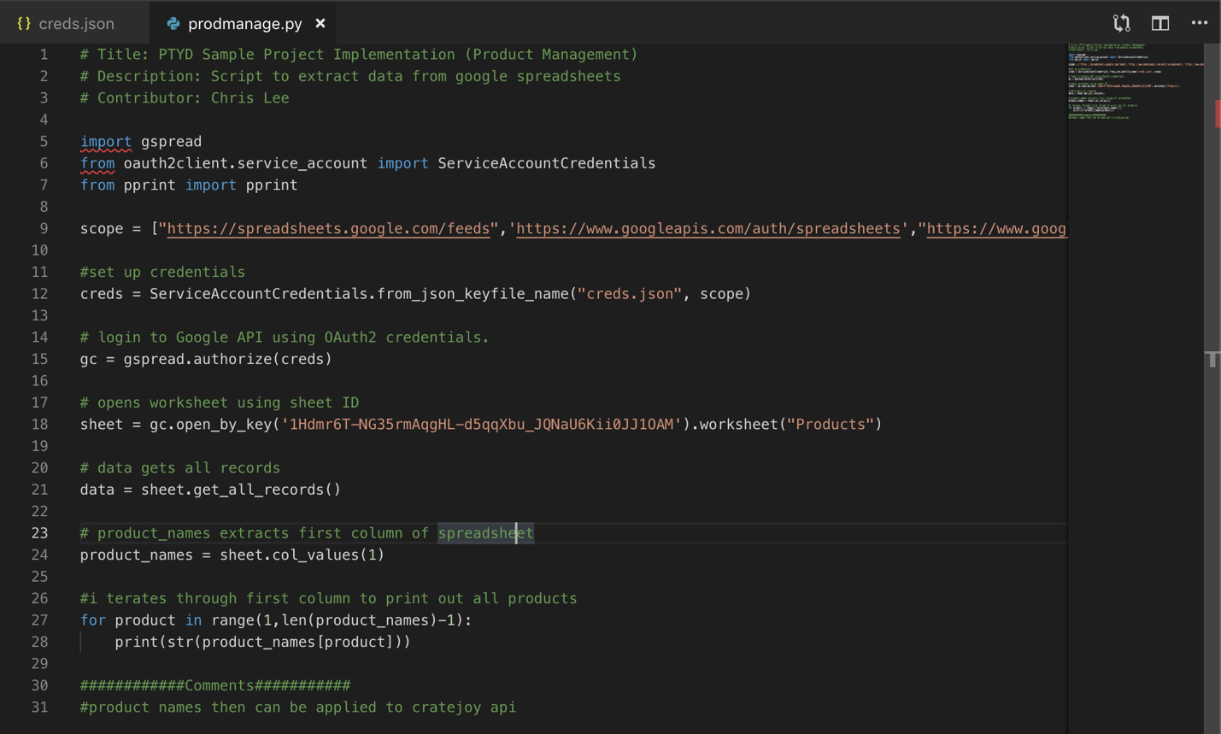

Terminal

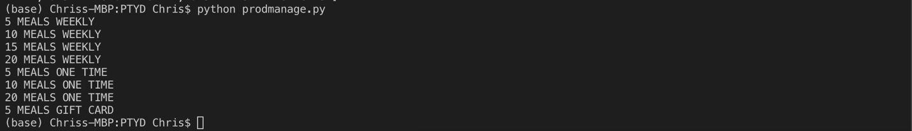

**Product Management**

What I Understand: Google sheets stores product information. Get product information from google sheets using API. Push information into the CrateJoy store using the product method. Can choose to display product properties (name, description).

**Management of Menu Information**

What I Understand: Google sheets stores menu information. Get menu information from google sheets using API. Push menu information into CrateJoy store.

**Downloading Information Related to Subscriptions**

What I Understand: Orders are collected by CrateJoy. Custom orders are created by Formstack. Use CrateJoy and Formstack API’s to get subscription data with Python script and push data into google sheets.

**Downloading One Time and Add-On Information**

What I Understand: Similar to subscription information except add-on information is generated through Formstack.

**Data Pull Code Review**

What I Understand: Python file contains functions to get various categories of orders from CrateJoy and pull into JSON file. Special orders information from Formstack still needs to be implemented using API.

**Data Pipeline Collation and Output**

What I Understand: main.py script functions to combine data from CrateJoy, Formstack, and Google Sheet in a useful form (make deliveries). Uses dictionaries to identify two main key/value pairs, customer id and phone number. Collated data considers overrides from permanent preferences and customizations/add-ons. Delivery data pulls delivery information which can be analyzed to optimize delivery routes.

**Printing Out Labels**

What I Understand: Get total of each menu item ordered using the collated data in the Python script. Push to a csv/spreadsheet to understand how many of each label needs to be printed.

**What Data to Archive**

What I Understand: Archive data automatically at the end of a week into JSON format in a storage file system. Archive data according to important business growth goals.

Suggestions: Implement data transfer into spreadsheet or possibly a SQL server using a cloud hosting service such as AWS. Using SQL allows for faster and safer queries of large data sets compared to using spreadsheet. More room for error when navigating spreadsheets to accidentally change a cell/data value.

**Fix/Change Suggestions:**

* When hovering mouse over the menu items, the menu information’s white text can be hard to read. Maybe having a dark overlay on the picture, like already done for the add-on page, would make for an easier reading experience.
* Not sure if this is already implemented but asking customers for a survey through text or email, during or at the end of their experience regarding information such as menu favorites, likes/dislikes, etc can provide valuable customer feedback.